

Hilal Sales Employee Portal

User Manual

**Content : Page No**

* **Adding User………………………………………………...3**
* **Editing User’s Access to Database…………………….4**
* **Adding Entity(Database)………………………………….5**
* **Customer Order Status…………………………………...6**
* **Customer Purchase History……………………………...6**
* **Customer Outstanding Status…………………………...7**
* **Stock Status…………………………………………………7**

1. **For Adding New Employee/User :**

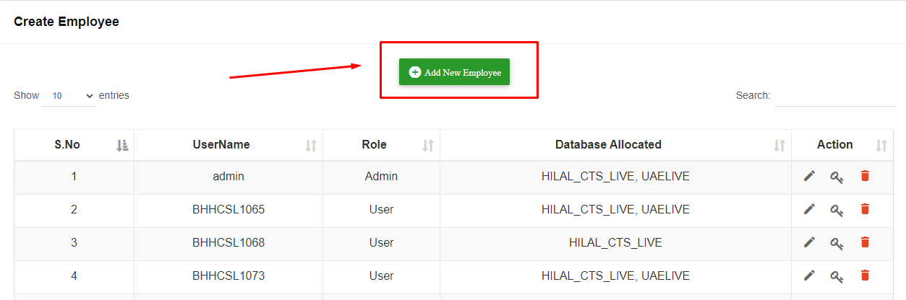

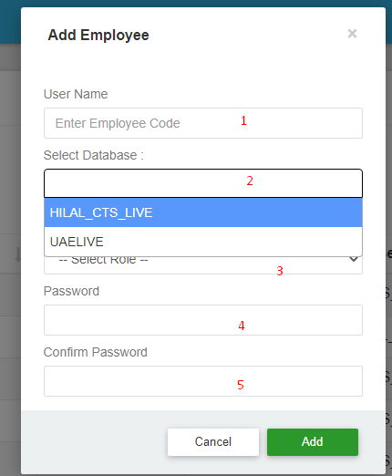

**Steps:**

1. Enter Employee Code Like BHHCSL1065 ,BHHCSL1063…..
2. Select Database* Which You want to Give Access to Particular Employee

( Which You Mentioned in ‘1’ Field )

1. Select Role of the Employee(Admin Or User)
2. Enter Password
3. Enter Confirm Password

* * What are the Database’s You Will Create in Entity Tab , It will Directly list Out Here

**2. For Editing Database Access to Particular Employee**

- Click on the Below **Specified Icon** for Editing Database Access to Particular Employee

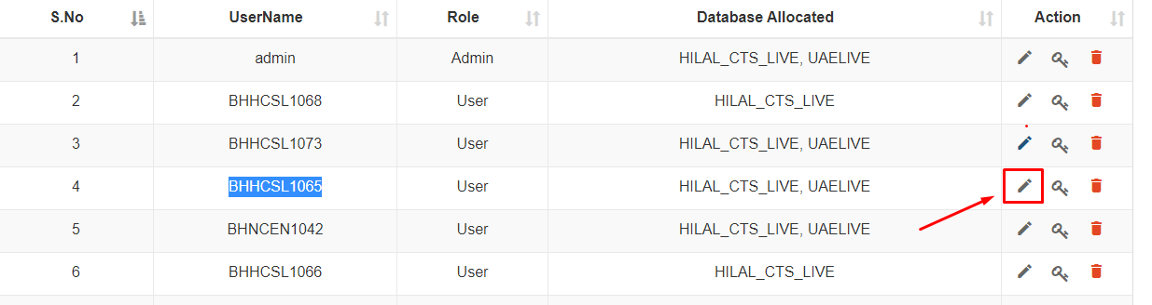

* After Clicking the Icon in Above Image , One Pop-Up(Below Image) Will Appear 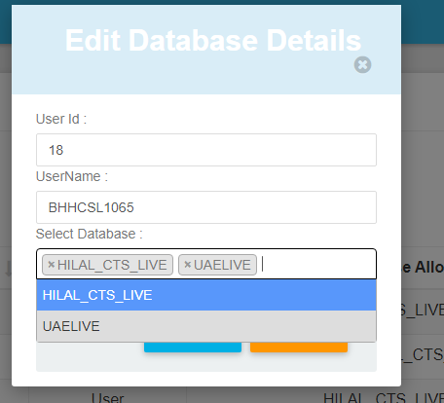

You Can Select or Deselect the Particular Database to Particular User in

**“Select Database”** Field

**3. Entity Screen :**

* **In this Screen We Can Add the Database’s**

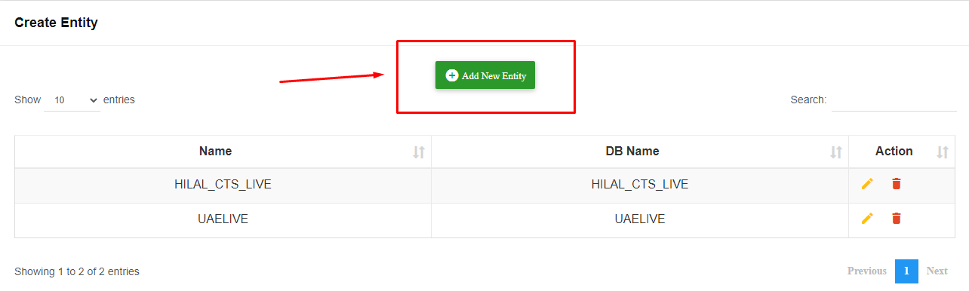

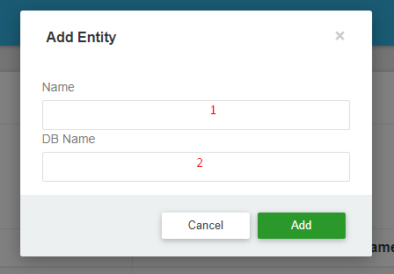

**Steps:**

**In 1 & 2 Fields Enter the Database Name**

* **Customer Order Status :**

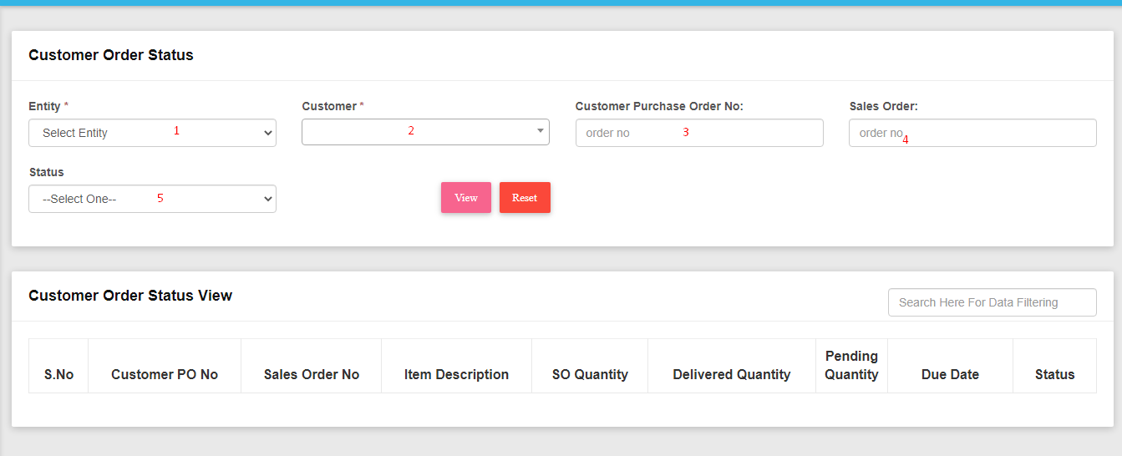

**Steps :**

1. **Select the Database (Allocated Database to Particular User’s Only Will List out Here)**
2. **Select the Customer Name (Only Certain Customer’s Related to Logged Sales Employee in Selected Database Will List Out here)**
3. **Enter Purchase Order No (Optional)**
4. **Enter Sales Order No (Optional)**
5. **Select the Status of the Sales Order(i.e., Invoiced,Open ,Placed Order to Vendor...)**

* **Customer Purchase History :**

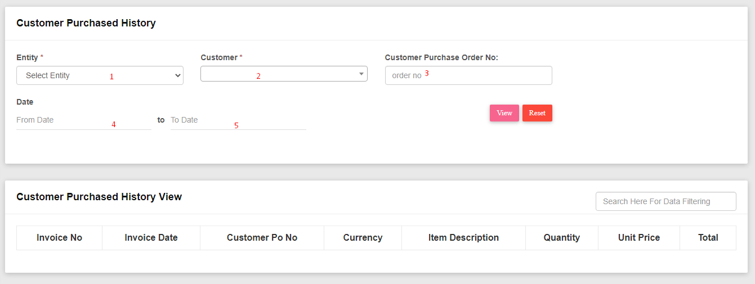

**Steps:**

1. **Select the Database (Allocated Database to Particular User’s Only Will List out Here)**
2. **Select the Customer Name (Only Certain Customer’s Related to Logged Sales Employee in Selected Database Will List Out here)**
3. **Enter Purchase Order No (Optional)**

**4 & 5 : Select From & To date(Optional)**

* **Customer Outstanding Status :**

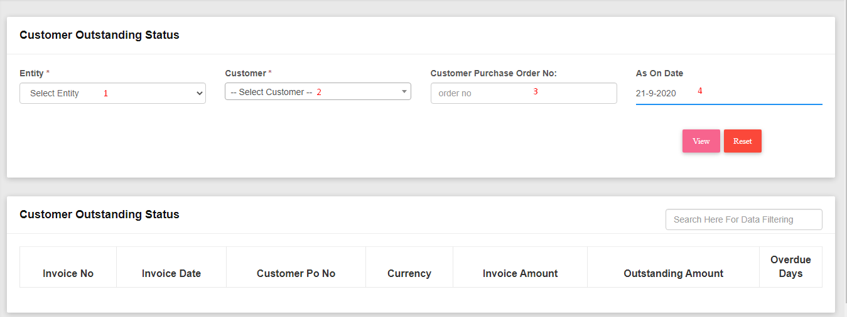

**Steps:**

1. **Select the Database (Allocated Database to Particular User’s Only Will List out Here)**
2. **Select the Customer Name (Only Certain Customer’s Related to Logged Sales Employee in Selected Database Will List Out here)**
3. **Enter Purchase Order No (Optional)**
4. **Select Date (By Default Today’s Date Will Display) (Optional)**

* **Stock Status :**

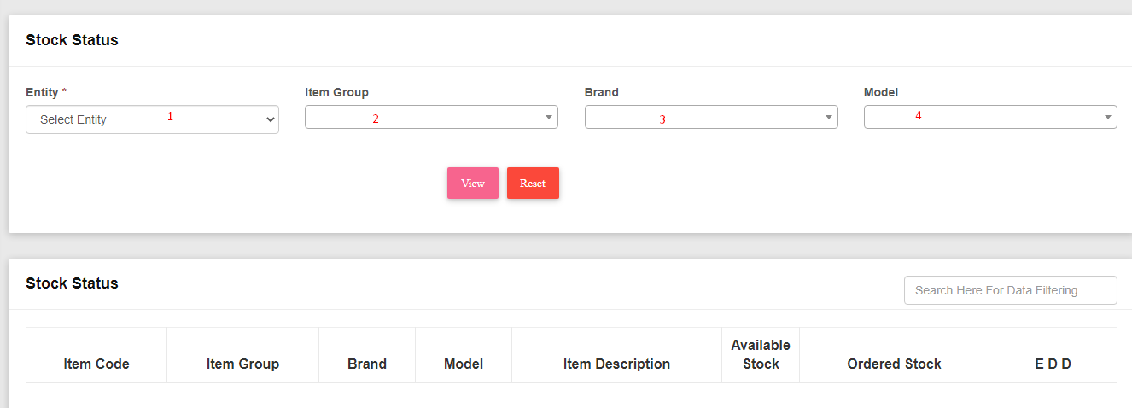

**Steps :**

1. **Select the Database (Allocated Database to Particular User’s Only Will List out Here)**
2. **Select Item Group (i.e., Client,Accessories,CISCO,Enterprises...)**
3. **Select Brand (Optional)**
4. **Select Model (Optional)**